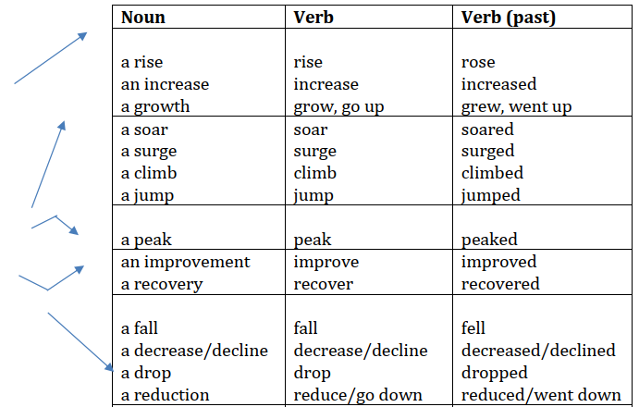

|  |  |  |  |  |  |
| --- | --- | --- | --- | --- | --- |
| dd |  |  |  |  |  |
|  | fdsa | fdsa | fds | á | dfs |
| Dsaf |  |  |  |  |  |
| adfs | fd | dfs | da | df | f |